# Salesforce Account Verification

**Project:** Courier Management System (CMS)
**Activity:** Verify account activation and access to the Salesforce project environment
**GitHub account:** `charlesaswinraj063-debug`
**Repository:** [courier-management-system.](https://github.com/charlesaswinraj063-debug/courier-management-system.)
**Documentation updated:** 24 September 2026

## Objective

Confirm that the project owner can access the intended Salesforce practice environment and the setup areas needed for the Courier Management System.

## Verification record

| Item | Current record |
| --- | --- |
| Salesforce login | Successful access confirmed by the project owner. |
| Account activation evidence | Email activation has not been separately confirmed for this record. |
| Practice environment type | Awaiting the project owner's confirmation. |
| Setup access | Awaiting the project owner's check in the project environment. |
| Verification date | Full verification is not yet recorded; the documentation update date above is not a completed-verification date. |
| Screenshot evidence | No Salesforce account screenshots have been supplied for this record. |

This is a verification worksheet. Successful sign-in has been reported by the project owner; the other checks and screenshot evidence have not yet been independently verified.

## 1. Confirm account activation

For a newly registered Developer Edition account, locate the Salesforce activation email, follow its verification link, and complete the password and security prompts. Salesforce describes this process in its [Developer Edition activation guide](https://help.salesforce.com/s/articleView?id=005298906&language=en_US&type=1).

If the existing account is already active and usable, record its actual status. For a course-provided environment or Trailhead Playground, follow the relevant course access instructions and mark a separate Developer Edition activation step as not applicable where appropriate.

## 2. Verify login and project access

Perform these checks in the environment intended for this project. Record **Pass**, **Fail**, or **Not applicable**, with a brief reason, after each check.

| Check | Action | Expected result | Actual result |
| --- | --- | --- | --- |
| Account sign-in | Sign in using the intended Salesforce account. | The Salesforce application opens. | Owner-reported success; evidence pending. |
| Correct environment | Confirm which practice environment is being used for the project. | The intended environment is identified. | Pending. |
| Setup | In Lightning Experience, open the gear menu and select Setup. | The Setup page opens. | Pending. |
| Object Manager | Open Object Manager in Setup. | Object Manager is accessible. | Pending. |
| App Manager | Search for App Manager using Setup's Quick Find box, then open it. | App Manager is accessible. | Pending. |

The navigation checks follow Salesforce's [custom-app setup guide](https://trailhead.salesforce.com/content/learn/projects/quickstart-devzone-app/devzone-app-1). Access to these pages supports later configuration work; it does not prove that the CMS features have been implemented.

If a check fails, record the visible error and resolve it before marking that check as passed.

## 3. Add screenshot evidence

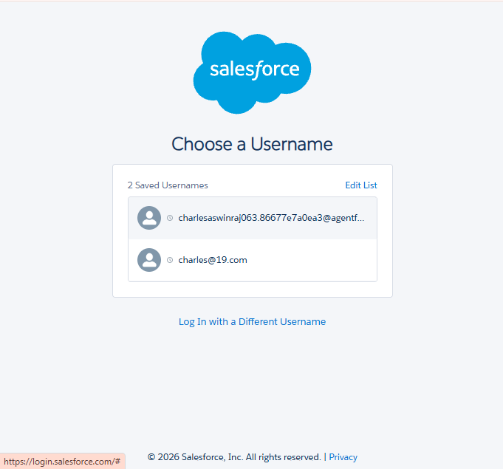
## 4. Record the outcome

Complete the following after performing the checks:

- **Verification date:** Awaiting completion of the applicable checks.
- **Overall result:** Partial — sign-in is confirmed by the project owner; activation evidence, environment type, and setup access still need confirmation.
- **Evidence filenames:** No screenshot evidence supplied for this record. Suggested names are listed above.
- **Unresolved issues:** Not yet assessed; no Salesforce error details have been supplied.

Mark the activity complete only after the applicable checks pass, the evidence is added, and any additional course requirements are met. This file alone does not certify account verification or change the course's progress percentage.

## Related document

[Salesforce Account Creation](SALESFORCE_ACCOUNT_CREATION.md)

